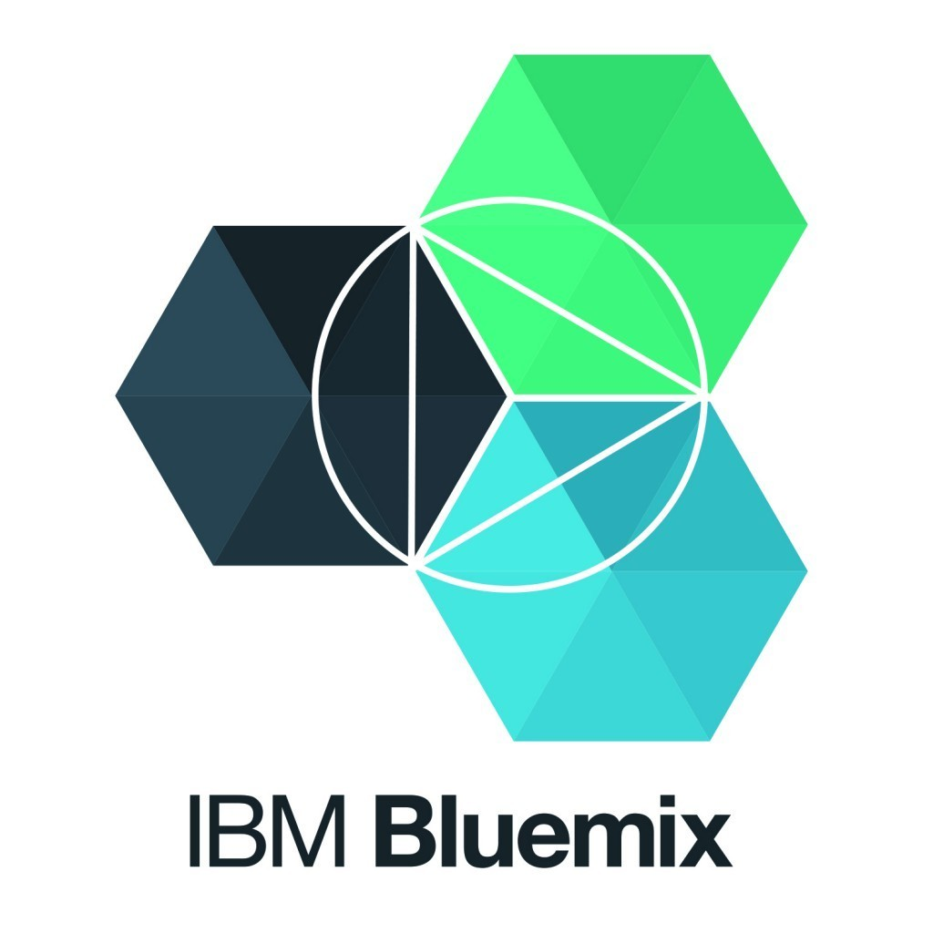
IoT Healthcare Simulator Powered by IBM Watson.

Step 1

Create IoT starter boiler plate app:
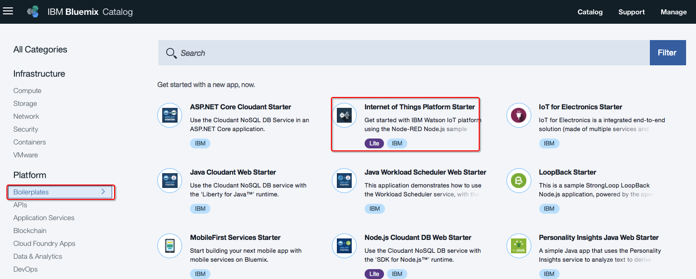

Step 2

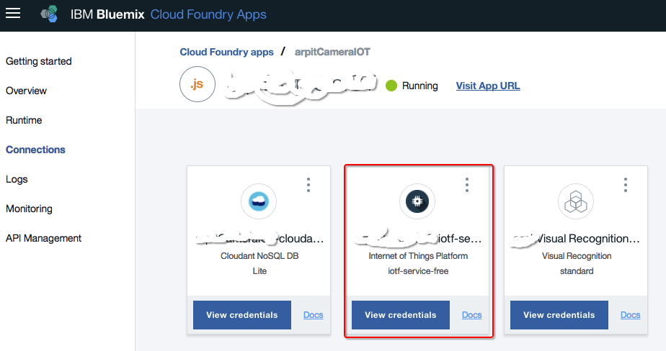
Register IoT devic
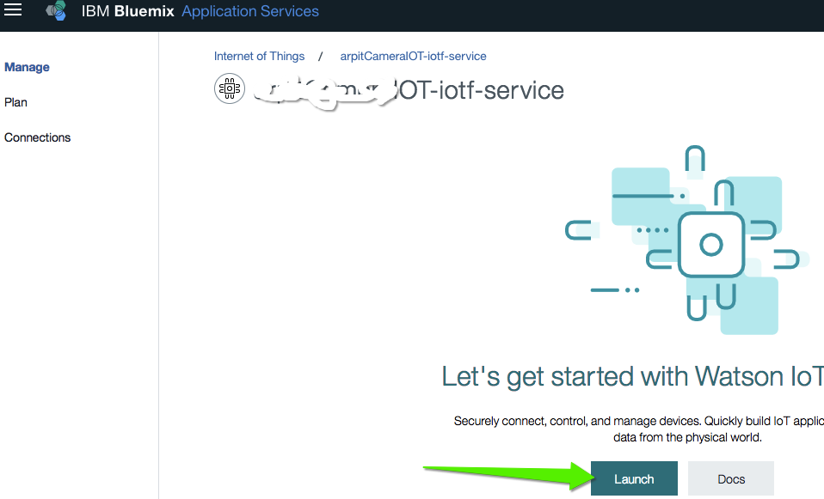
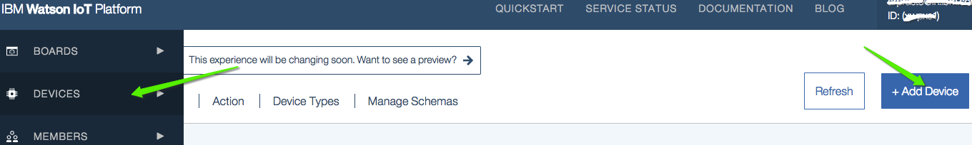
Step 3

Get below parameters after registering device:

- Organization ID
- Device Type
- Device ID
- Authentication Method
- Authentication Token

Step 4

Download Owntracks from Google playstore and update HTTPS url with above parameters.

https://orgId.messaging.internetofthings.ibmcloud.com:8883/api/v0002/device/types/typeId/devices/deviceId/events/eventId

Note: use Username as “use-token-auth”

Step 5

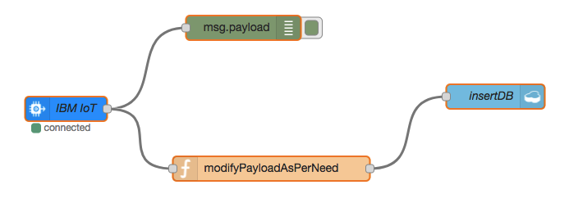
Simulate IoT device in Node Red:

Take json from (https://github.com/arprasto/LabDemo/blob/master/IoTSimulatorWithOwntracks.json)

Ref: https://developer.ibm.com/recipes/tutorials/send-location-and-status-data-of-your-mobile-device-to-the-watson-iot-platform-with-owntracks/

